Pulse sensor

1. connect sensor as shown in pic
2. upload code
3. use tools > serial monitor > set baud rate. To see output

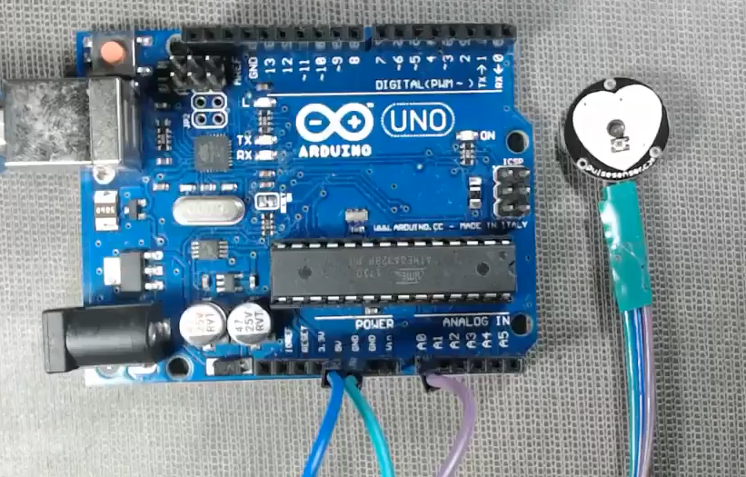

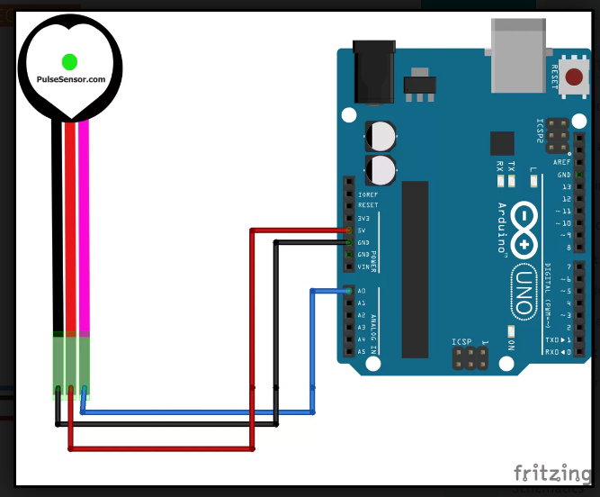

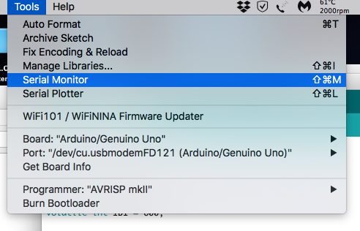

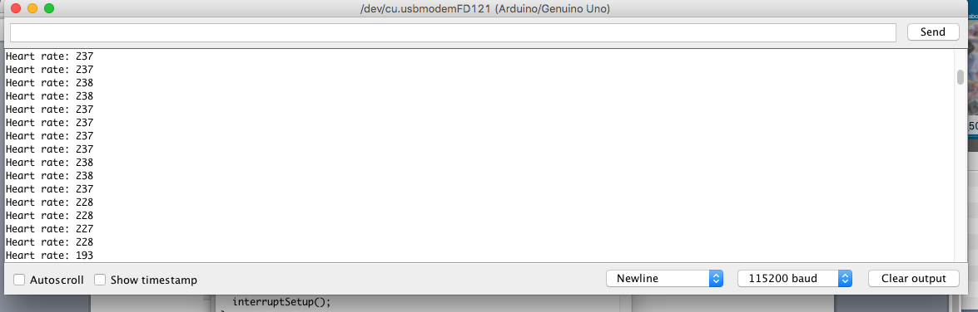

code

// Sensor and pins variables

int pulsePin = 0;

int blinkPin = 13;

// Pulse rate variable

volatile int BPM;

// Raw signal

volatile int Signal;

// Interval between beats

volatile int IBI = 600;

// Becomes true when the pulse is high

volatile boolean Pulse = false;

// Becomes true when Arduino finds a pulse

volatile boolean QS = false;

void setup(){

// Start Serial

Serial.begin(115200);

// Sets up to read Pulse Sensor signal every 2mS

interruptSetup();

}

void loop(){

// If heart beat is found

if (QS == true) {

// Print heart rate

Serial.print("Heart rate: ");

Serial.println(BPM);

// Reset the Quantified Self flag for next time

QS = false;

}

// Wait 20 ms

delay(20);

}